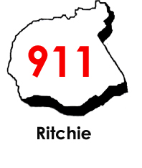

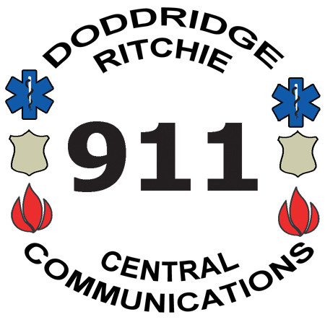
Central Communications, Inc.
4317 Lamberton Road, P.O. Box 516
Pennsboro, WV 26415
Phone: 304-659-3770 Fax: 304-659-3772
Mapping & Addressing: 304-659-2979
www.centrale911.com

Executive Director
Eric E. Ashcraft
Board of Directors
Samuel Rogers
Clinton Means
Shawn Glaspell
Steve Ritter

Recording Request – Public Safety Agency Use

Central Communications Inc., (CCI) will provide radio and/or telephone recordings to agencies that it serves on a regular basis, for purpose of internal investigative and/or personnel issues only. Once the information is turned over to said agency it is the sole responsibility of the requesting agency to ensure that the information is used only for the purposes of internal investigative/personnel issues. CCI will not be responsible for this information once it has left the CCI facility.
The signatures of the person representing the agency shall certify that the recording(s) are being provided by CCI for internal issues to the agency, and will not be used for court purposes.
Requesting agency agrees to provide a replacement CD or if they wish to use a cassette tape, provide a tape to CCI for the recording.

Call Number(s) : | Subject :

Date of Incident : | Time of Incident :

Requesting Agency : | Request Date:

Requesting Officer:

Reason for Issue :

Text of call details? Audio recording?

911 Call Phone Traffic Radio Traffic

Recorded by: | Date:
Signature

Released by authority of:

CCI Officer: | Date:
Signature

Released to: | Date:
Signature

On behalf of: | Date:
Company/Agency

Ver. 13 07/25/23

